**Assignment -1**

Python Programming

|  |  |
| --- | --- |
| Assignment Date | 19 September 2022 |
| Student Name | Ms Kaavya S |
| Student Roll Number | 111519205017 |
| Maximum Marks | 2 Marks |

**Question-1:**

Develop a sample homepage with html,css which should include banner,image and description about yourself and contact form.

|  |
| --- |
| **Solution:** |
|  |
|  |  |
|  |  |
|  |  |
|  |  |
|  |  |
|  |  |
|  |  |
|  |  |
|  |  |

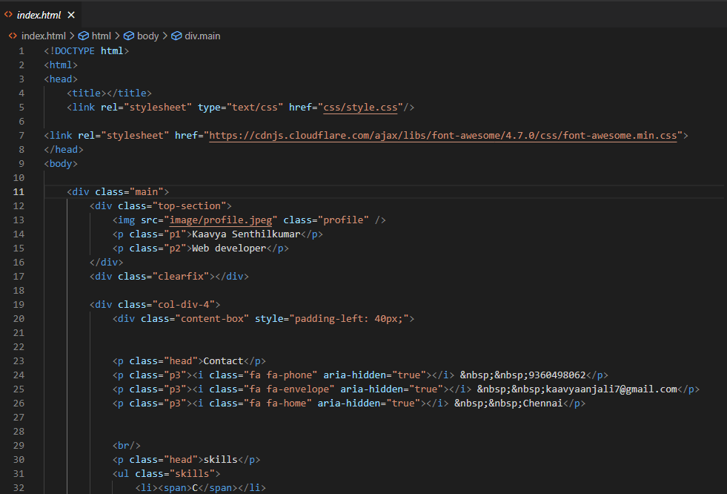

|  |  |
| --- | --- |
|  |  |
|  |  |
|  |  |
|  |  |

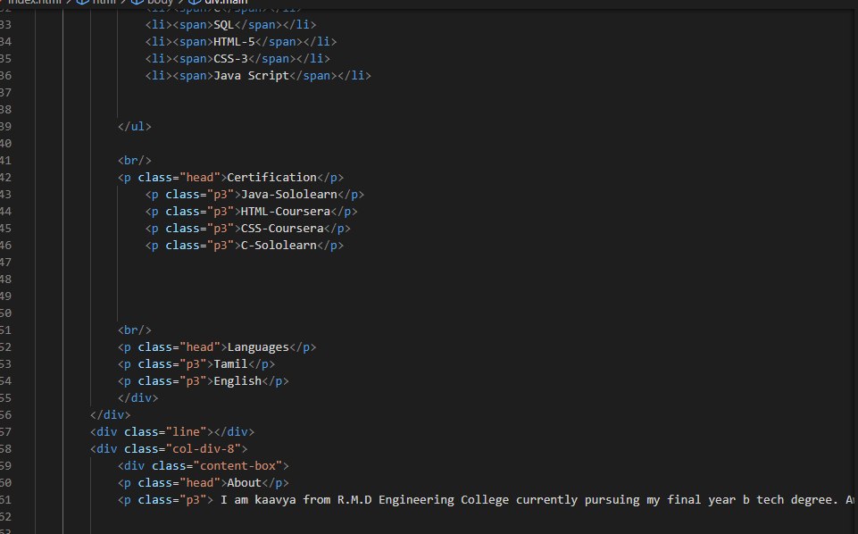

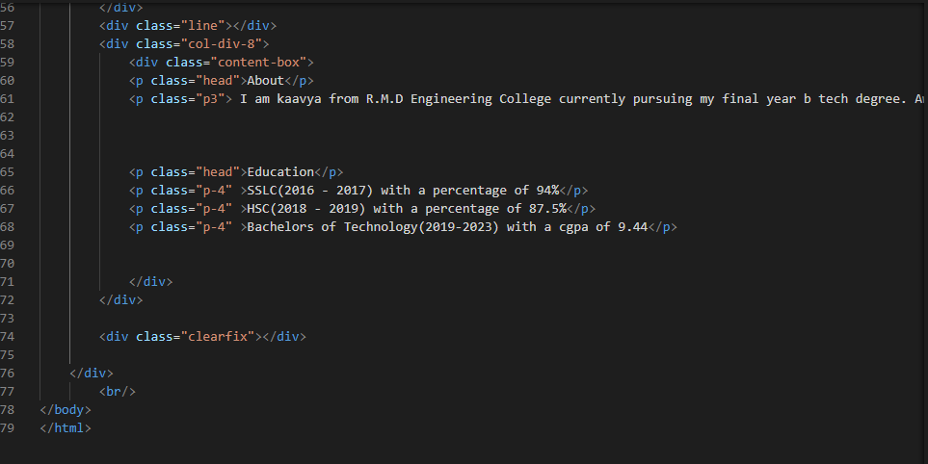

CSS

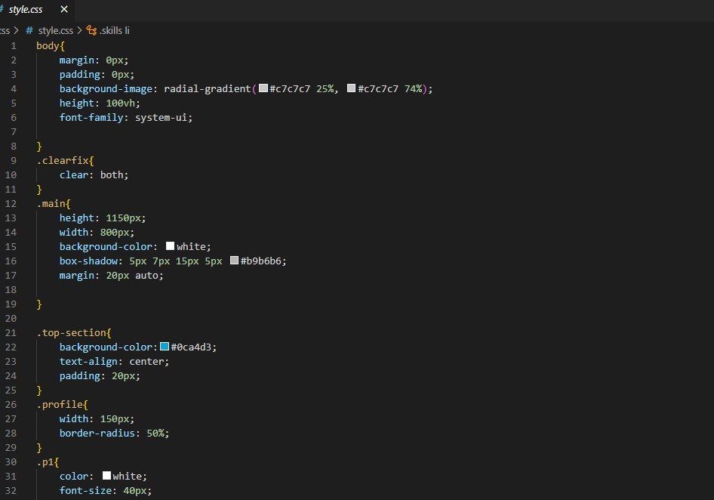

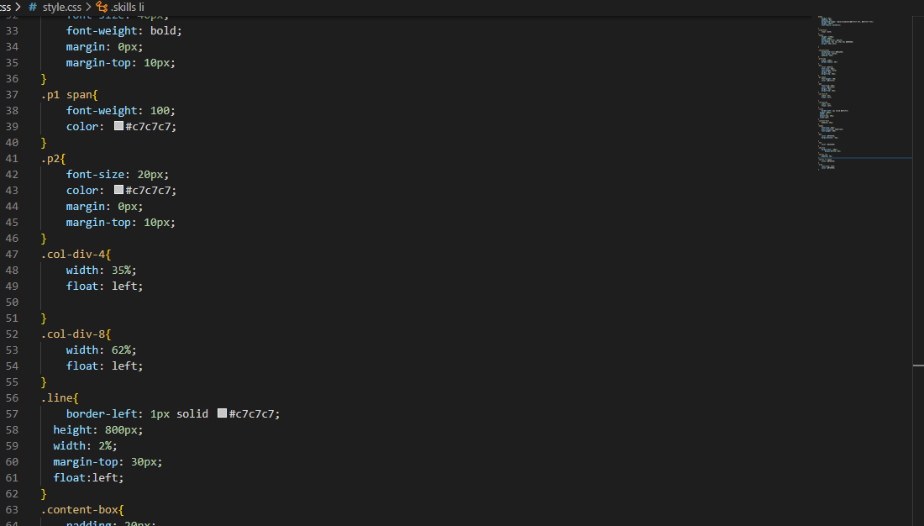

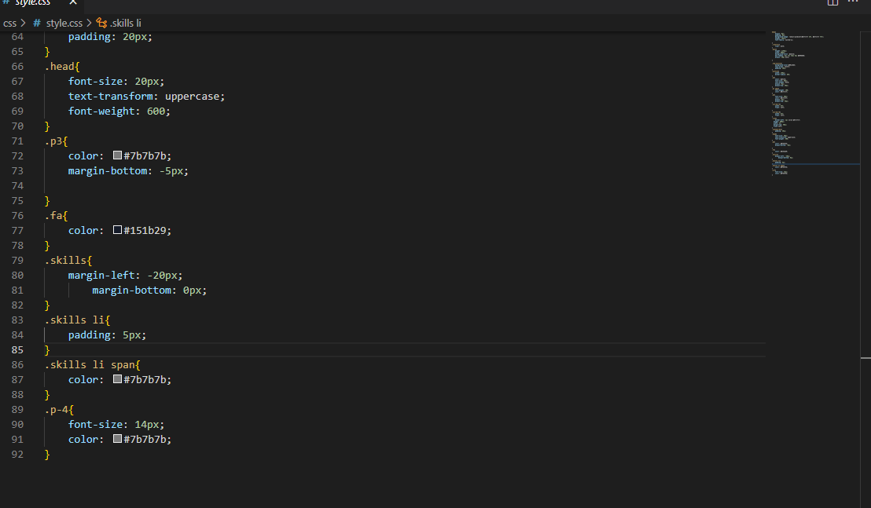

Output:

